Updates done after this year payment

* Recognizable increase in performance of website.
* Currently the whole content of EBC is uploading on website and sharing to other social media platforms (Facebook, Tweeter, and Telegram.). If you see Ethiopian Broadcasting corporation Facebook page and telegram pages, news contents are from website like as follows.

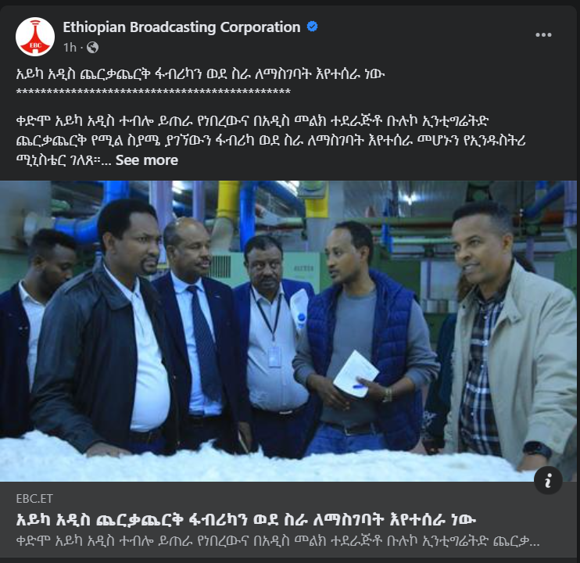

* 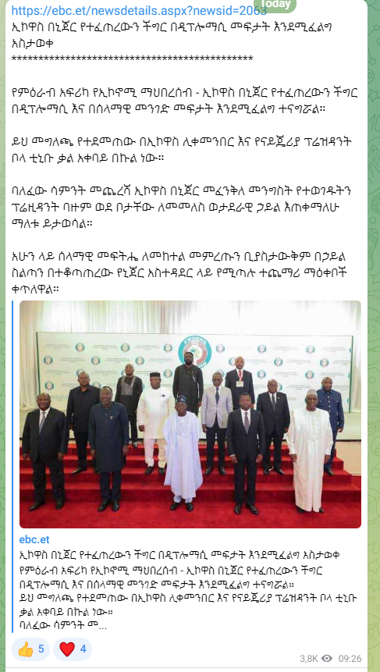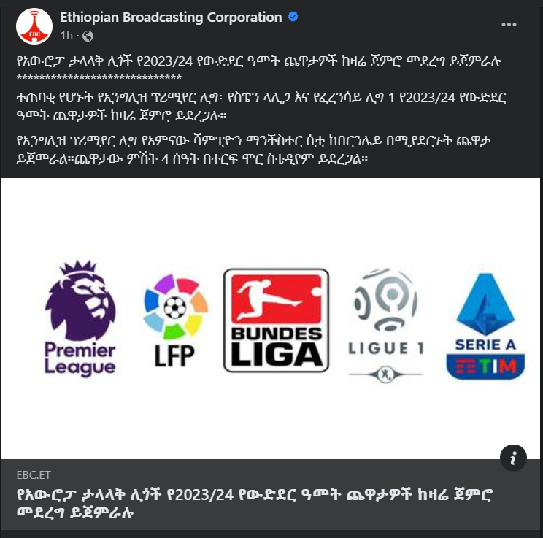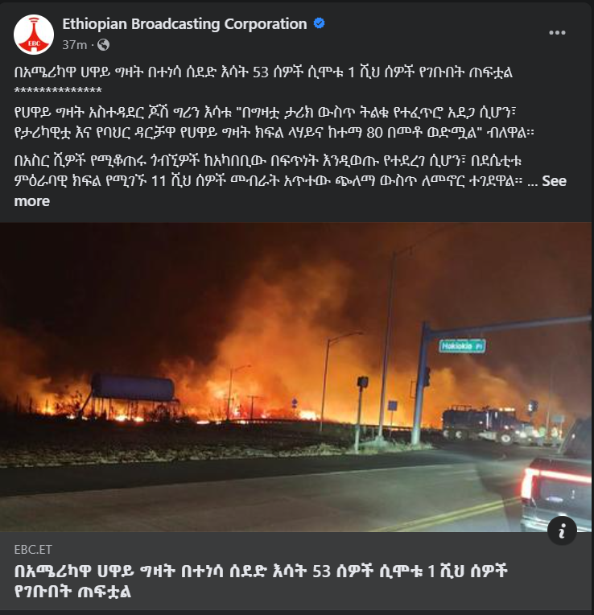
* Cyber-Media team is very comfortable on website now.

Ongoing task

Subdomains websites

* Database design for all subdomain websites
* Admin side development

User management

News management

Advert management

Menus management

Categories management

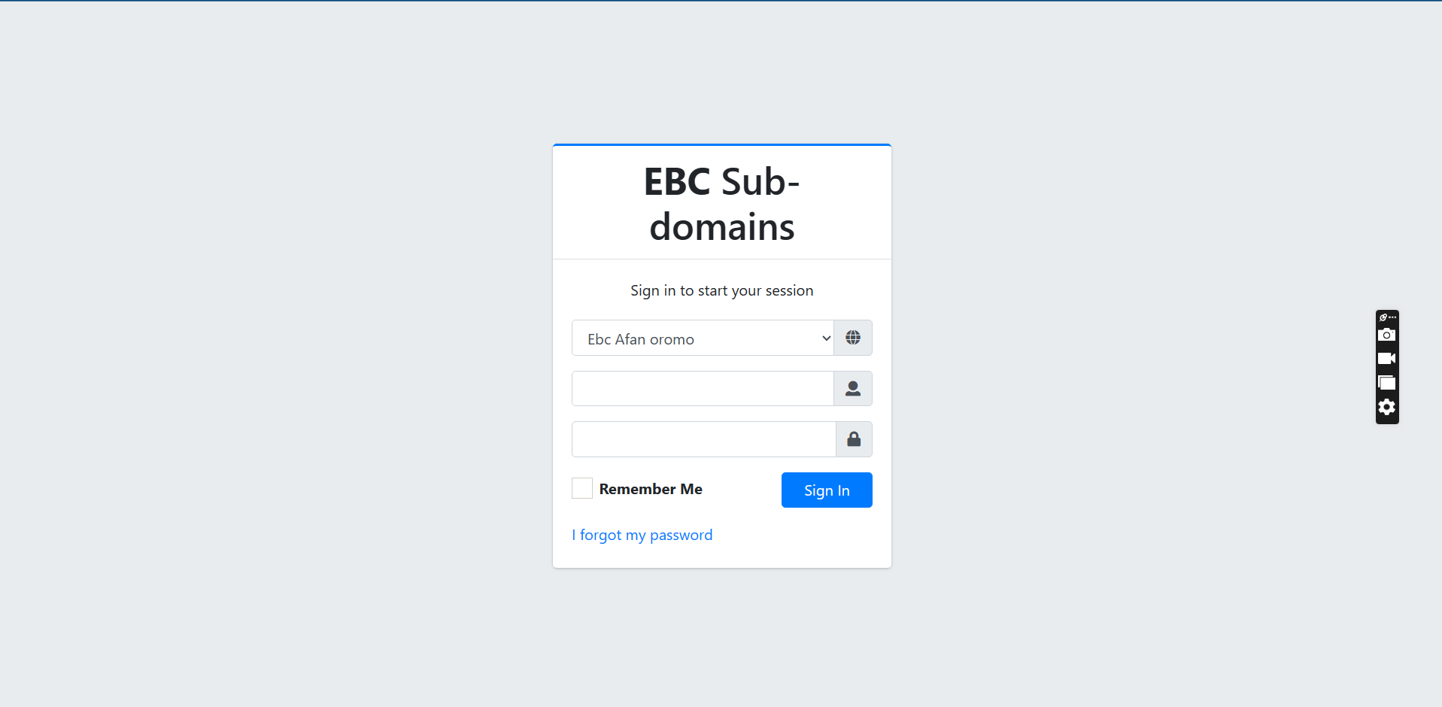

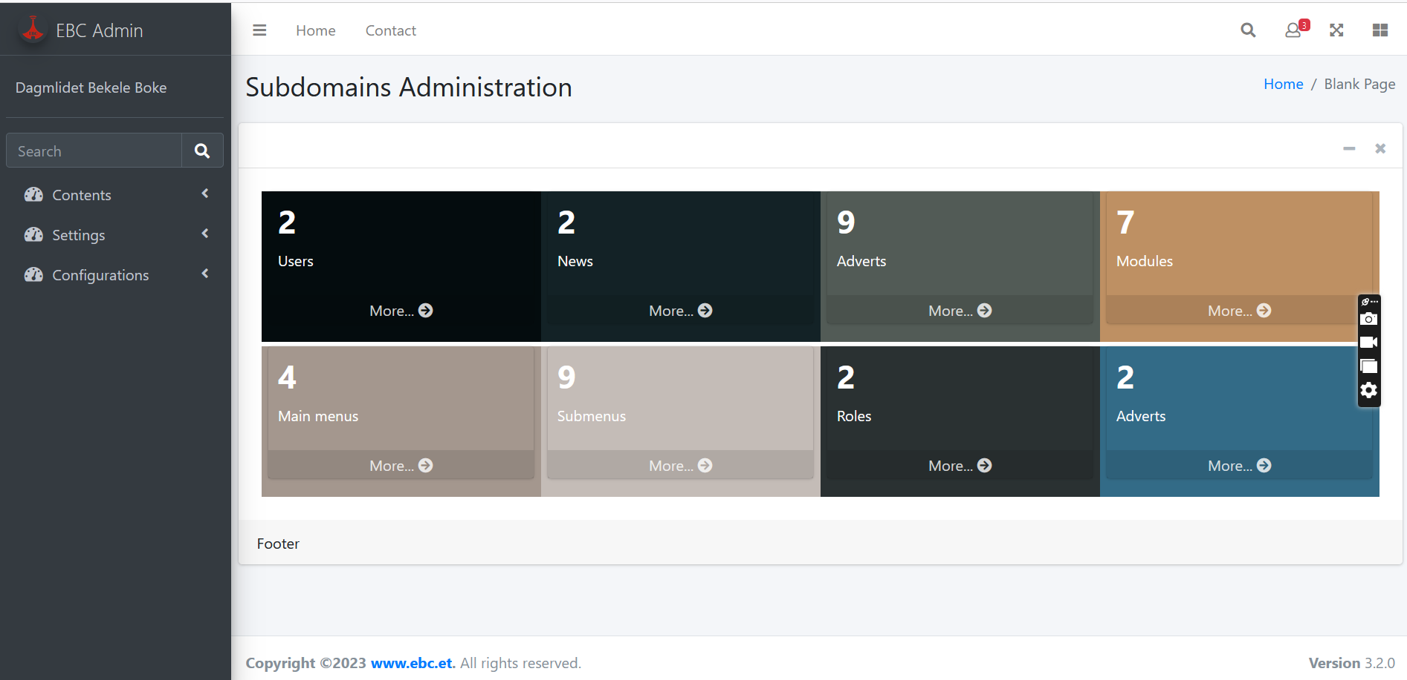

* Afan oromo website(ebc.et/afanoromo)

UI/UX design

Database design

UI/UX design interface is upproved by graphics for all subdomain websites. Note that we use the same design by changing their logo and their color. I will send you websites screen recordings by telegram.

* Tigrinya website(ebc.et/Tigrinya)

UI/UX design

Database design

* Somali website(ebc.et/Somali)

UI/UX design

Database design

* Arabic website(ebc.et/Arabic)

UI/UX design

Database design

* French website(ebc.et/French)
* Ebc job portal (jobportal.ebc.et)

UI/UX design

Database design

* Mobile application(Cross platform, android and IOS)

UI/UX design

Database design

API (application interface development)

Some of the sample pages shown below

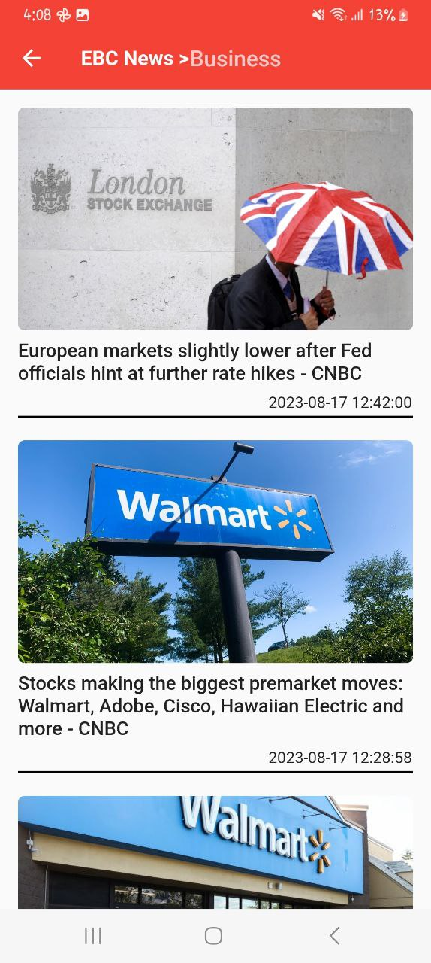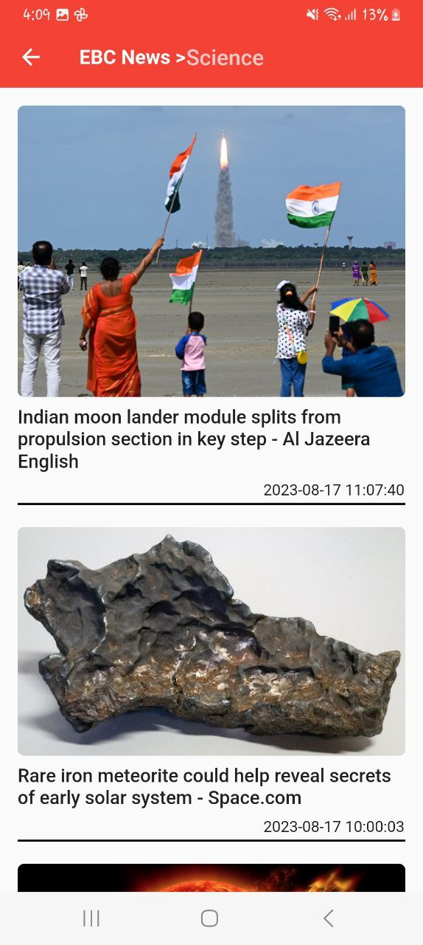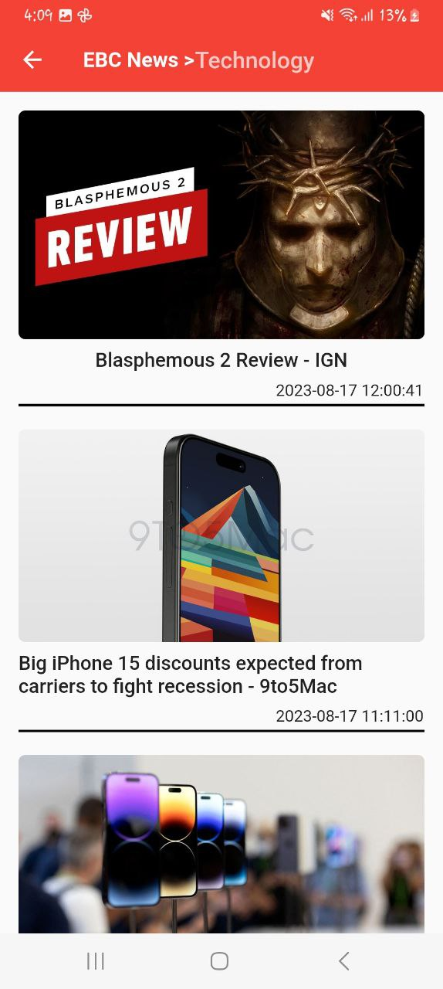

* Live streaming :-

Challenge I faced is creating an email for [webmaster@ebclive.net](mailto:webmaster@ebclive.net) email. This email is mandatory for creating SSL certificate for ebclive.net domain, which is necessary for livestreaming. I am trying to figure out the problem. As soon as this issue is fixed I will start live streaming.